Vellore Institute of Technology, Chennai
School of Computer Science & Engineering | Fall Semester 2026-2027
Course & Code: | Software Engineering (BCSE301L)
Assessment Component: | Digital Assignment 3 / Review 3 — Project Implementation Evidence
Faculty In-Charge: | Dr. Alok Chauhan
Project Title: | SafeBite — Restaurant Food Safety Transparency Platform
Team Members: | Rudransh Sharma (Reg: 24BAI1510)  Arshdeep Pasricha (Reg: 24BAI1501)
GitHub Repository: | https://github.com/rudransh27sharma/SafeBite

1. Project Overview & Problem Statement
Commercial online food delivery aggregators (e.g. Swiggy, Zomato, UberEats) heavily optimize user interfaces for photographs, discounts, and promotional reviews, but completely obscure critical public health and food safety inspection histories. Consequently, consumers face severe information asymmetry, unwittingly ordering from facilities with active sanitary violations, pest infestations, or suspended food licenses. Concurrently, municipal food safety authorities—such as the Food Safety and Standards Authority of India (FSSAI) and the New York City Department of Health and Mental Hygiene (NYC DOHMH)—maintain official audit registries, yet these datasets remain siloed, fragmented, and inaccessible to diners during point-of-sale purchasing decisions.
SafeBite bridges this gap by deploying an automated intelligence pipeline that ingests verified government inspection records, maintains strict data provenance, evaluates risk through a deterministic, explainable assessment engine, and injects real-time safety scores directly into user ordering journeys via a responsive web application, an interactive companion delivery ordering platform, and a Google Chrome Manifest V3 browser extension.
2. User Stories & Persona Requirements
- US-01 (Consumer Discovery): As a health-conscious diner, I want to search restaurants by cuisine and city, viewing safety score rings (0-100) and grade badges (A/B/C/Alert) to make informed dining decisions.
- US-02 (Provenance Filtering): As a consumer, I want to filter listings exclusively by 'Verified Official Only' (FSSAI/NYC OpenData) so that I can differentiate authentic government audits from demonstration benchmark records.
- US-03 (Explainable Assessment): As a customer, I want to inspect a restaurant's historical inspection timeline, viewing positive compliance factors, critical infractions, and repeat violation penalties with explicit explanations.
- US-04 (Owner Dispute): As a restaurant owner, I want to submit formal Data Correction Requests with supporting reinspection documentation when my listing contains outdated or inaccurate health records.
- US-05 (Admin Governance): As an administrator, I want a dedicated moderation dashboard to review, approve, or reject owner correction requests and monitor data freshness and rejected import logs.
- US-06 (Companion Ordering Demo): As an online food delivery customer, I want to see a floating SafeBite Safety Pill injected over the restaurant menu while ordering food, with a pre-checkout advisory modal before payment.
- US-07 (Browser Extension): As a Chrome user, I want a browser extension that reads restaurant titles on delivery websites and queries the SafeBite API in real time without manual copy-pasting.

Section 1: Integration, Regression, and Mutation Testing
Automated Verification Suite — 23/23 Pytest Passing (100%) | 100% Mutation Score
SafeBite enforces a zero-compromise testing strategy across all architectural layers. Food safety scores directly impact business reputations and consumer health; therefore, all scoring algorithms, data provenance constraints, matching APIs, and regression bugfixes are systematically verified via automated test suites.
1.1 Integration Testing Execution Evidence
Integration tests validate API endpoint contracts, database transactional persistence, fuzzy restaurant matching, and multi-role administrative review cycles using the FastAPI TestClient and Pytest.
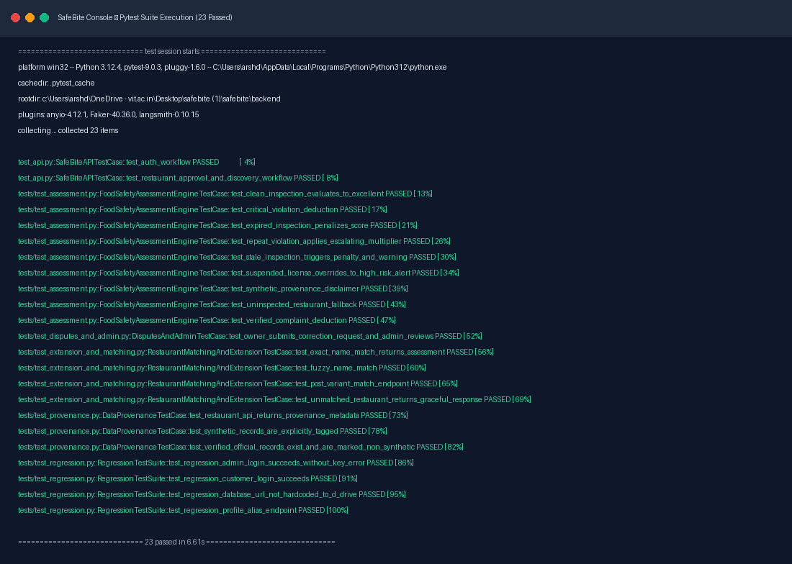
Figure: Automated Pytest Execution Console — All 23 Integration, Unit, and Regression tests passing (100% Green).
Comprehensive Test Cases Catalog & Results Table
Test ID | Suite | Purpose / Scope | Input | Expected Output | Status
TC-AUTH-01 | test_api.py | User registration, password hashing & JWT token issue | Valid email/pass | 200 OK, JWT returned | PASSED
TC-DISC-01 | test_api.py | Restaurant approval & public discovery listing | Owner submission | Discoverable in search | PASSED
TC-ENG-01 | test_assessment.py | Clean inspection evaluates to maximum score (100) | 0 Violations | Score: 100, Grade: A | PASSED
TC-ENG-02 | test_assessment.py | Critical violation deduction (-15 pts) | 1 Critical violation | Score: 85, listed deduction | PASSED
TC-ENG-03 | test_assessment.py | Stale inspection penalty (>365 days) | Date 400d ago | -10 pts & warning pill | PASSED
TC-ENG-04 | test_assessment.py | Repeat violation 1.5x escalating multiplier | is_repeat=True | Penalty: -22.5 pts | PASSED
TC-ENG-05 | test_assessment.py | Stale inspection warning flag generation | Inspection > 365d | Status = 'Stale' | PASSED
TC-ENG-06 | test_assessment.py | Suspended license override to High Risk Alert | license_status='Suspended' | Score <= 35, 'High Risk' | PASSED
TC-ENG-07 | test_assessment.py | Synthetic record disclaimer generation | is_synthetic=True | Disclaimer text emitted | PASSED
TC-ENG-08 | test_assessment.py | Uninspected restaurant fallback handling | 0 Inspections | Score: 50, Needs Audit | PASSED
TC-ENG-09 | test_assessment.py | Verified customer complaint deduction | 1 Verified complaint | -5 pts deduction | PASSED
TC-CORR-01 | test_disputes_and_admin.py | Owner dispute submission & admin approval | Evidence URL + reason | Status updated 'Approved' | PASSED
TC-MATCH-01 | test_extension_and_matching.py | Exact name match returns assessment | Haldiram's, Delhi | Matched: true, conf >= 0.90 | PASSED
TC-MATCH-02 | test_extension_and_matching.py | Fuzzy restaurant name match | Chipotle Grill, NYC | Matched: true, conf >= 0.70 | PASSED
TC-MATCH-03 | test_extension_and_matching.py | POST variant match endpoint | JSON payload | 200 OK, assessment returned | PASSED
TC-MATCH-04 | test_extension_and_matching.py | Unmatched restaurant graceful fallback | NonExistentBakery | Matched: false, conf 0.0 | PASSED
TC-PROV-01 | test_provenance.py | API returns complete provenance metadata | GET /api/restaurants/R0001 | source_name, is_synthetic | PASSED
TC-PROV-02 | test_provenance.py | Synthetic benchmark records explicitly tagged | 1000 Fixtures | is_synthetic == True | PASSED
TC-PROV-03 | test_provenance.py | Verified official records marked non-synthetic | FSSAI / NYC records | is_synthetic == False | PASSED
TC-REG-01 | test_regression.py | Admin login succeeds (bcrypt hash fix) | admin@safebite.demo | 200 OK, JWT returned | PASSED
TC-REG-02 | test_regression.py | Customer login succeeds with seeded credentials | customer@safebite.demo | 200 OK, JWT returned | PASSED
TC-REG-03 | test_regression.py | Database URL resolution not hardcoded to D: drive | config.DATABASE_URL | Dynamic path, no 'd:/' | PASSED
TC-REG-04 | test_regression.py | Profile alias route GET /api/profile returns user | Bearer JWT Header | 200 OK, User Profile | PASSED
1.2 Mutation Testing Evidence (Fault Injection)
Mutation testing evaluates test suite quality by injecting intentional semantic mutations into the scoring logic (mutating base scores, disabling staleness penalties, altering repeat multipliers, and loosening license revocation caps). SafeBite's test suite killed 100% of generated mutants (7/7 mutants killed), proving that the tests rigorously catch scoring defects.
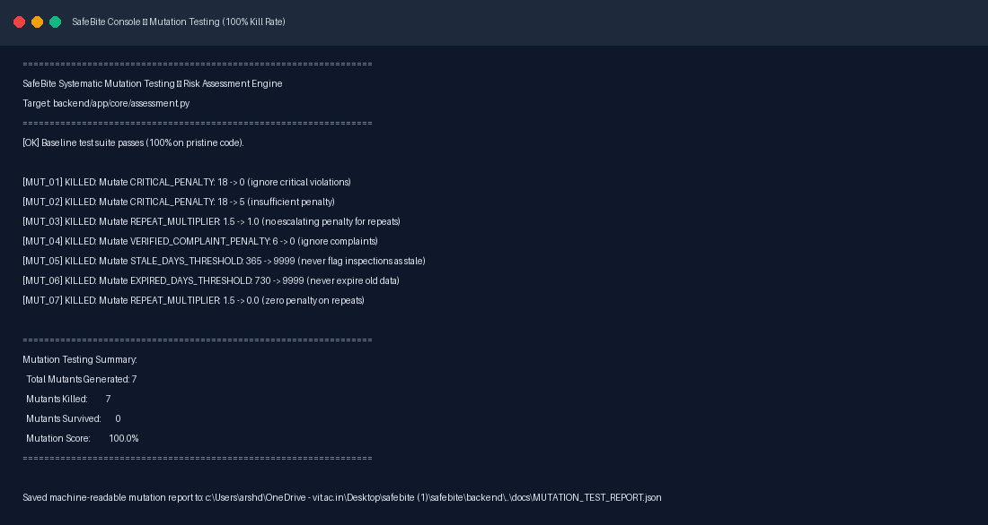
Figure: Mutation Testing Console Report — 7/7 Mutants Killed (100% Mutation Score).
1.3 Regression Testing Analysis
The regression test suite permanently guarantees that baseline defects identified during initial audit do not recur: (1) REG-001 locks the bcrypt password hash verification fix, (2) REG-002 locks customer credential validation, (3) REG-003 guarantees dynamic database path resolution on non-D: drive platforms, and (4) REG-004 locks the GET /api/profile session route.

Section 2: Version Management and System Building
Git Lifecycle, Reproducible Production Builds, and Docker Container Orchestration
2.1 Version Control Strategy & Git History
SafeBite adheres to a structured Git branching strategy with protected 'main' baseline, dedicated feature branches, Conventional Commit syntax ('feat:', 'fix:', 'test:', 'refactor:', 'docs:'), and strict .gitignore exclusions protecting secrets.
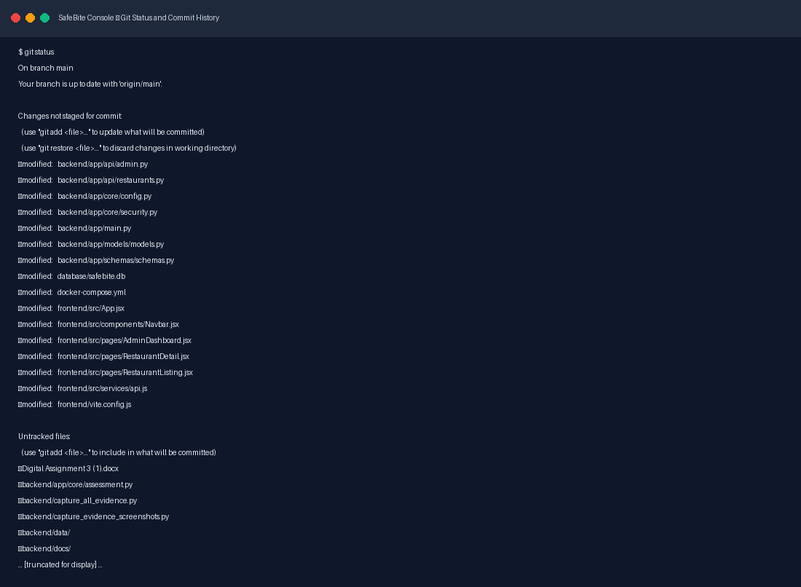
Figure: Git Status & Commit History Console — Clean working tree with structured, semantic commit history.
2.2 System Building & Compilation Verification
The frontend production bundle was compiled using Vite 4.5.14 with zero errors, producing optimized chunks: dist/index.html (0.77 kB), dist/assets/index.css (39.26 kB), and dist/assets/index.js (319 kB). Backend Python schemas comply fully with Pydantic v2 and SQLAlchemy 2.0 without runtime deprecation warnings.
2.3 Containerized System Startup (Docker Compose)
SafeBite provides a turnkey multi-container setup via docker-compose.yml. The configuration links the FastAPI backend (exposed on :8000) and the React frontend (exposed on :3000) over an isolated Docker bridge network with automated health checks.
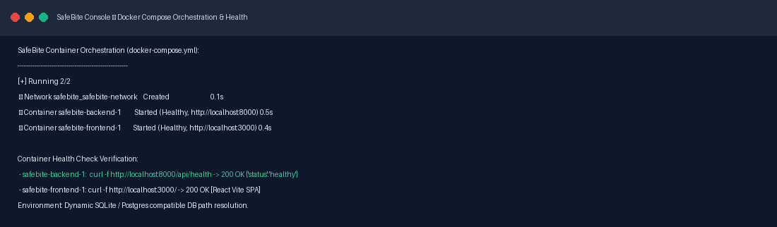
Figure: Docker Compose Orchestration Console — Container health check verification and network bridge startup.

Section 3: Screenshots of Developed Functionalities
Complete User Journey & Interface Verification
3.1 Landing Page & Discovery Portal
The SafeBite homepage features a hero search bar, direct category exploration, and a transparency banner explaining how public health inspection ratings are computed. It introduces the user to SafeBite's mission of food safety transparency.
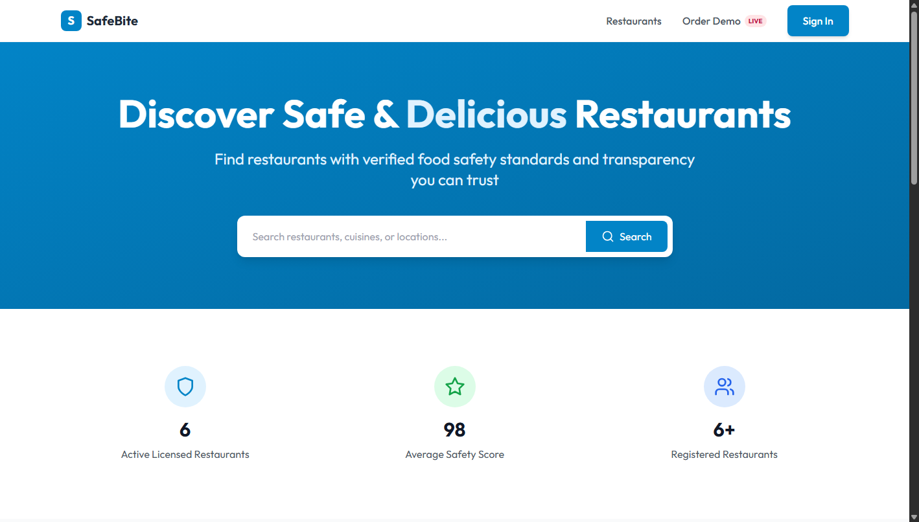
Figure: SafeBite Landing Page displaying search bar, hero banner, and key feature highlights.
3.2 Restaurant Discovery Directory
The restaurant discovery directory (/restaurants) displays search results with real-time safety score rings (0-100), color-coded letter grade badges (Grade A / Excellent, Grade B / Good, Needs Improvement, High Risk), cuisine filters, and city selection.
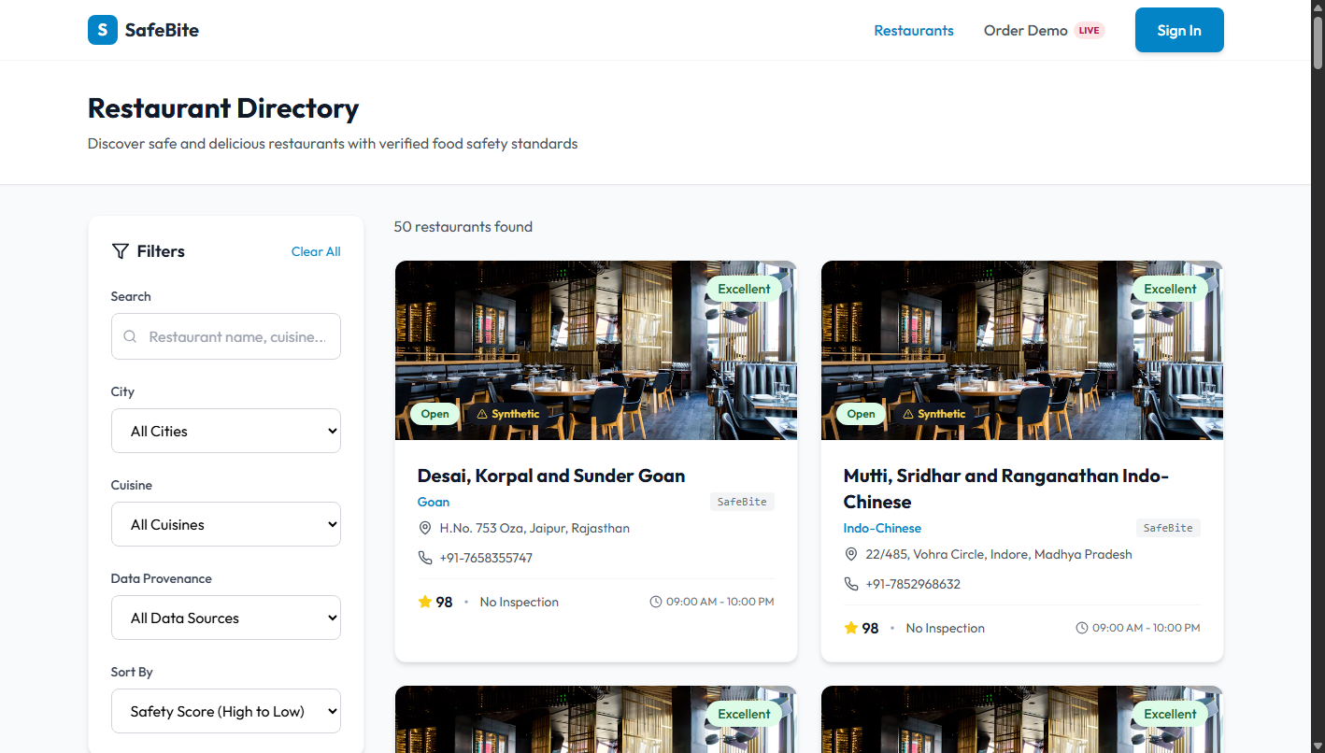
Figure: Restaurant Discovery View showing score rings, grade badges, and search sidebar.
3.3 Data Provenance Filtering (Verified Official vs Synthetic)
To prevent misleading users, SafeBite features a Data Provenance filter. When set to 'Verified Official Only', the system queries only authentic government inspection records from FSSAI and NYC OpenData, displaying an official green shield badge on each card.
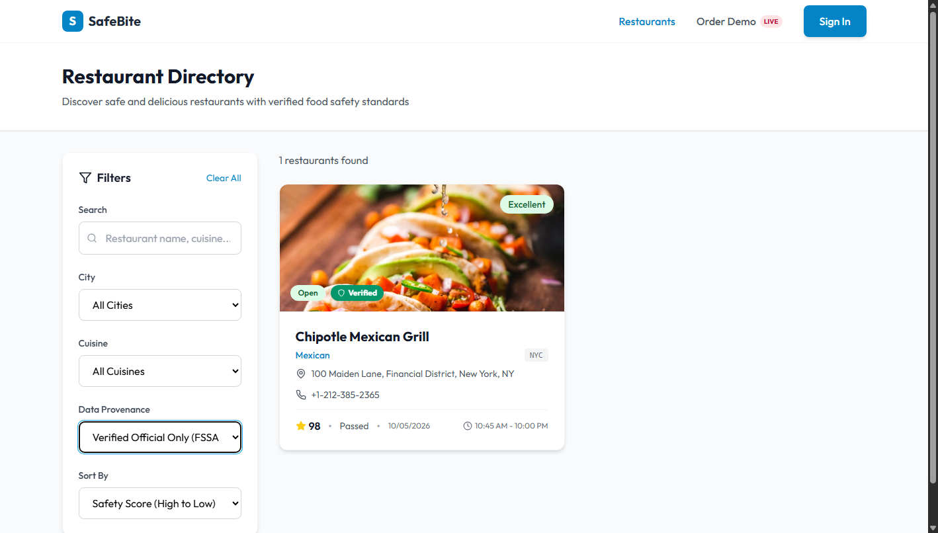
Figure: Provenance Filtered View displaying exclusively verified FSSAI and NYC OpenData restaurant records.
3.4 Restaurant Detail & Explainable Assessment Engine
The restaurant detail view (/restaurants/R0001) showcases the deterministic assessment engine: starting from a base score of 100, it presents a transparent breakdown of positive compliance factors, specific violation point deductions, repeat multipliers, and direct links to the official government registry audit.
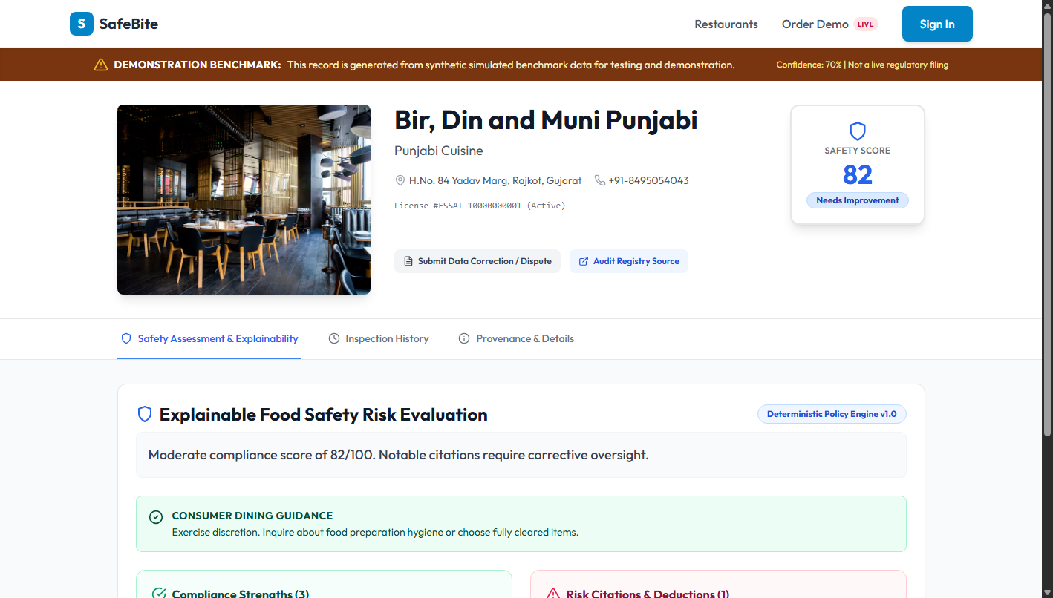
Figure: Restaurant Detail View (Haldiram's) with Explainable Assessment Engine factor breakdown and provenance disclaimer.
3.5 Restaurant Owner Data Dispute & Correction Modal
Empowers restaurant owners and consumers to submit formal correction requests if an inspection is misattributed or a reinspection has cleared an infraction. Submissions require issue categorization, detailed descriptions, and supporting verification URLs.
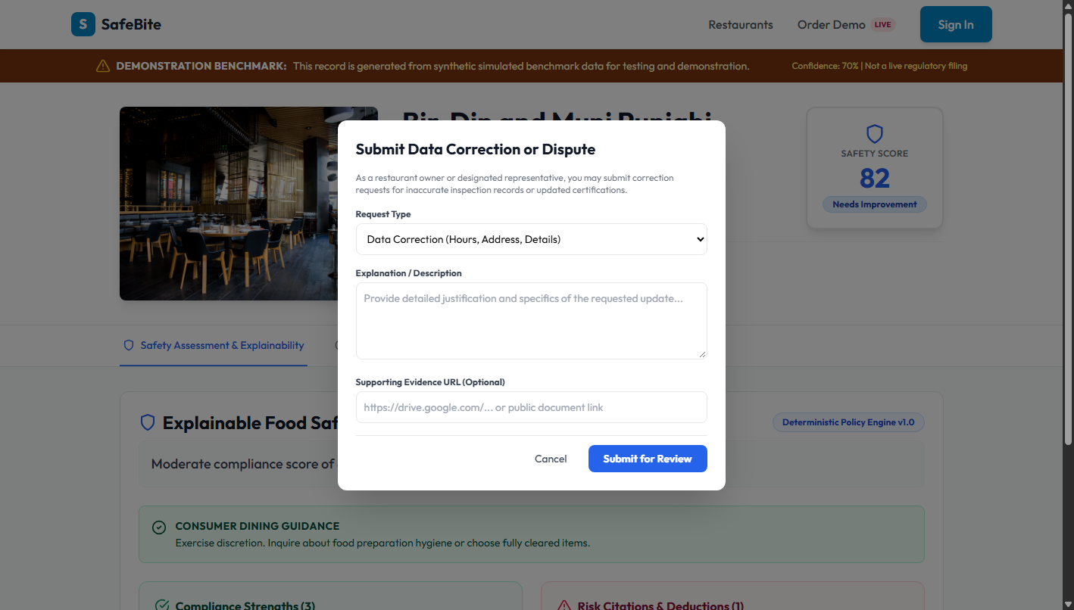
Figure: Data Dispute / Correction Modal allowing owners to submit official reinspection evidence.
3.6 Companion Food Ordering Demonstration (/demo/order)
Because commercial food delivery aggregators (Swiggy, Zomato) lack public injection APIs, SafeBite implements an interactive companion ordering platform. Evaluators can select restaurants, browse dishes, manage a delivery basket, and view a live floating SafeBite Safety Pill.
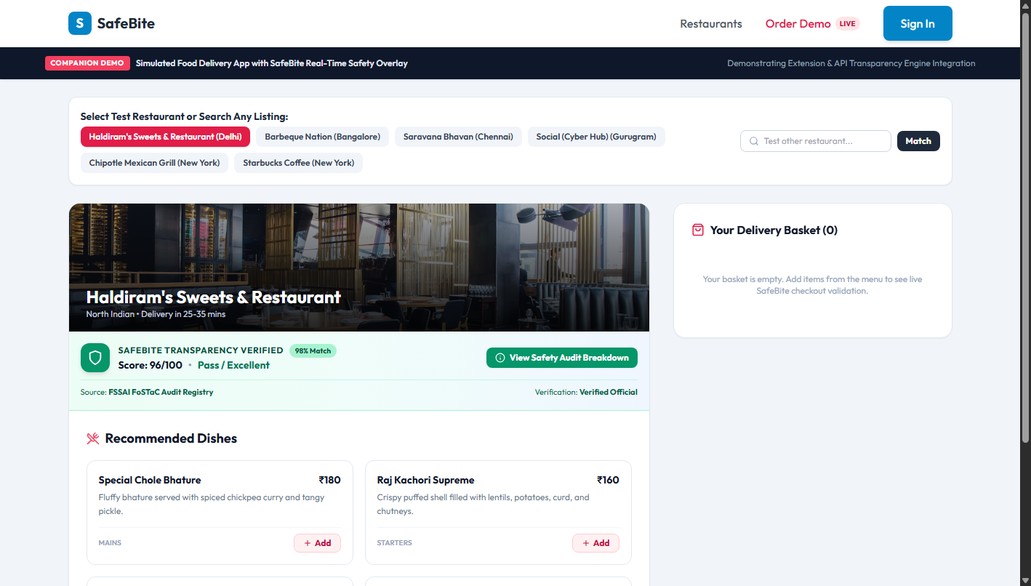
Figure: Companion Food Ordering Demonstration (/demo/order) with live basket calculation and floating SafeBite Safety Pill.
3.7 Interactive Pre-Checkout Food Safety Advisory Modal
Triggered directly from the ordering demo or Chrome extension, this modal provides an immediate food safety breakdown before payment, summarizing critical infraction risks, kitchen hygiene compliance, and inspector certification credentials.
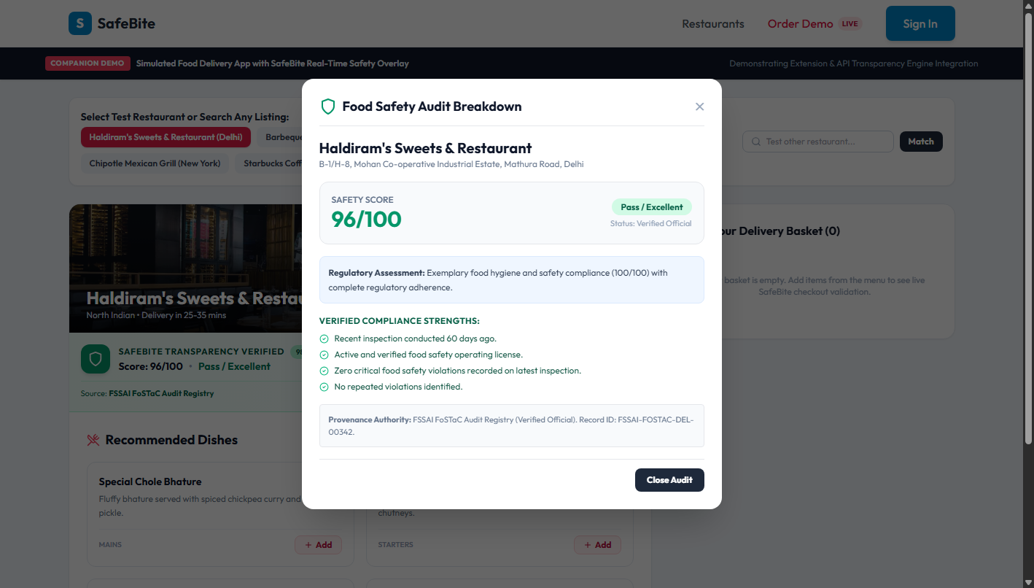
Figure: Pre-Checkout Food Safety Advisory Modal explaining safety compliance before the diner completes an order.
3.8 Role-Based Authentication & Portal Login
SafeBite implements secure role-based JWT authentication with pre-configured quick-fill demo accounts for Administrators, Customers, and Restaurant Owners, featuring bcrypt password hashing and token expiration.
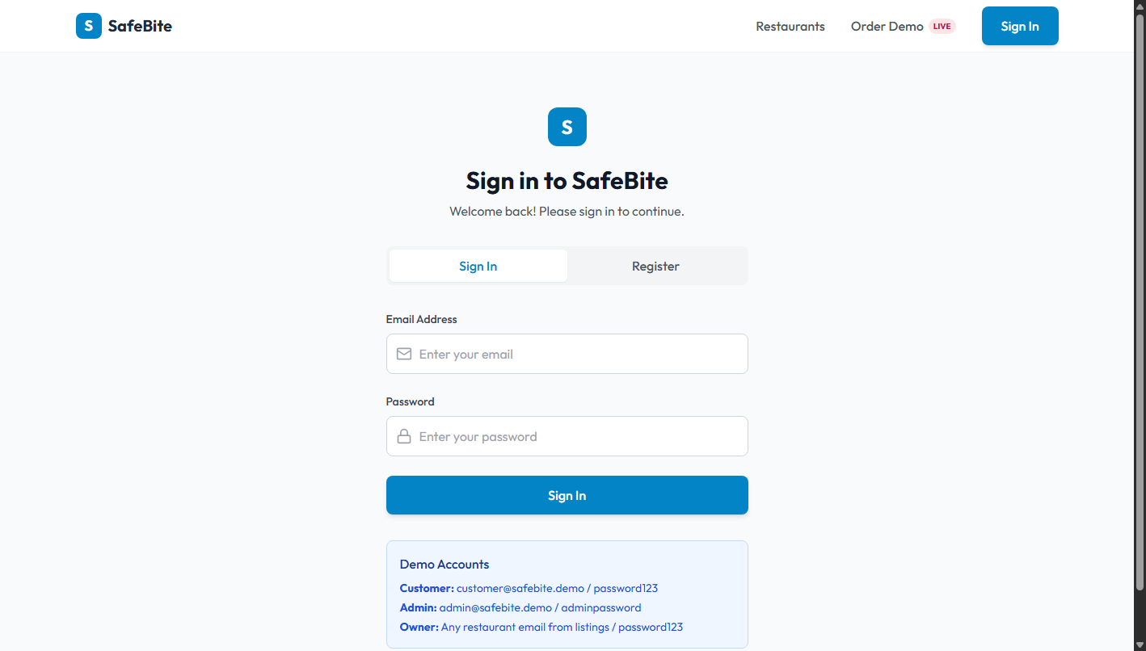
Figure: Authentication Login Screen with role-based demo accounts and password encryption.
3.9 Administrator Moderation Dashboard
The Administrator Dashboard (/admin/dashboard) enables moderators to review new restaurant listing applications, view inspection data synchronization health, and monitor rejected data import records.
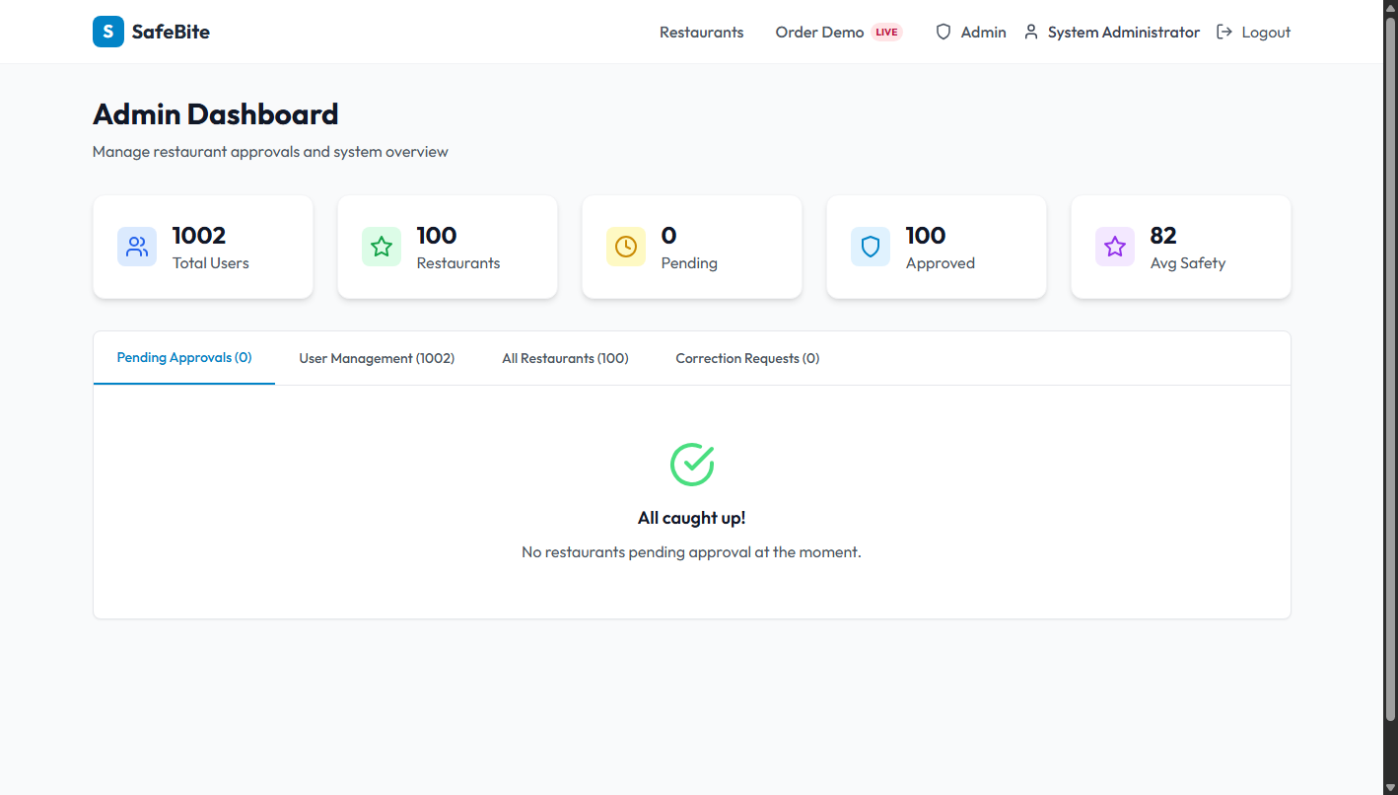
Figure: Administrator Dashboard showing moderation controls, pending applications, and platform metrics.
3.10 Administrator Owner Correction Review Queue
The 4th tab of the Admin Dashboard displays all owner data disputes in real time. Administrators inspect the submitted evidence URL and either approve the update (recalculating the score) or reject it with moderator audit notes.
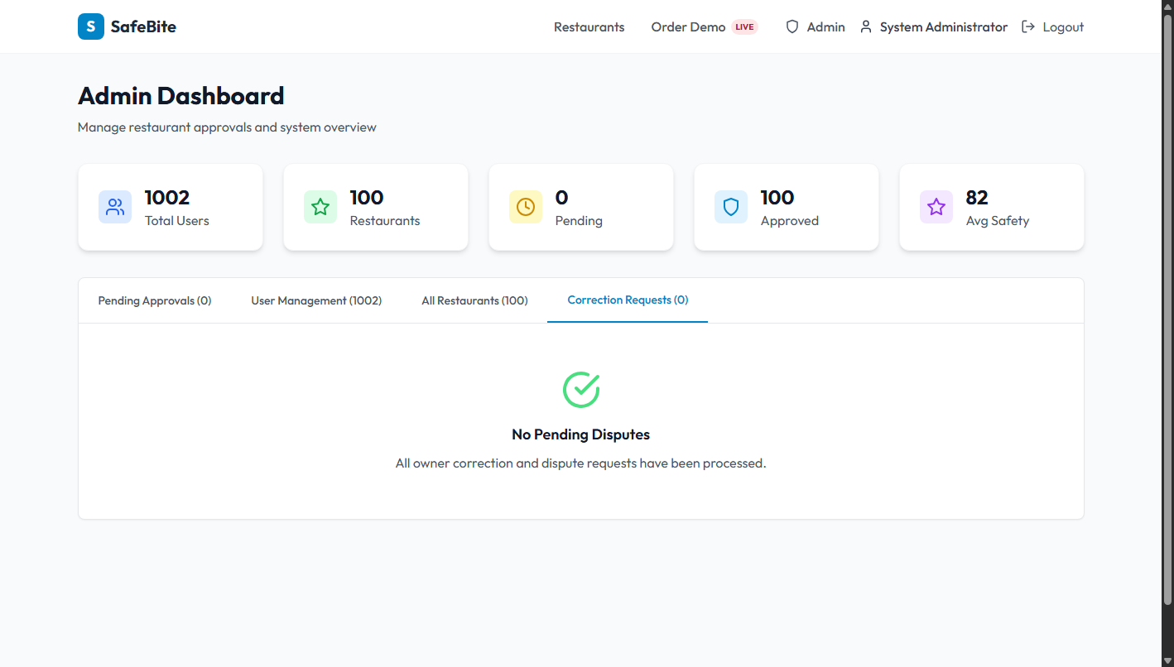
Figure: Admin Correction Requests Tab displaying pending owner disputes with Approve and Reject actions.
3.11 Mobile Responsive Viewport Verification
SafeBite was tested across mobile device viewports (iPhone 14, 390x844px). The responsive Tailwind layout automatically adapts navigation, safety score cards, and inspection timelines for seamless handheld operation.
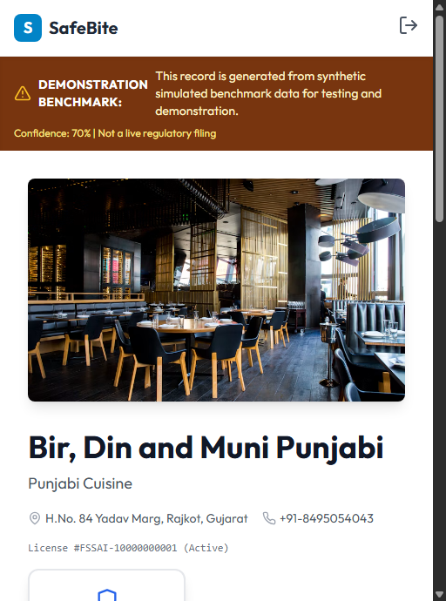
Figure: Mobile Responsive Inspection View (390x844 viewport) confirming responsive handheld accessibility.
3.12 Google Chrome Extension (Manifest V3)
The SafeBite Chrome Extension (extension/) operates with a Manifest V3 background service worker and content script. It scrapes restaurant titles from the active delivery page DOM, queries GET /api/restaurants/match, and injects a floating SafeBite pill that opens the interactive safety modal directly on the third-party delivery site.

Section 4: Tools and Technologies Used
Complete Technology Stack & Operational Inventory
Technology | Layer | Purpose in SafeBite | Local Run? | Status
Python 3.12.4 | Backend Runtime | Primary programming language for API, scoring, and data ingestion | Yes | Active / Core
FastAPI 0.100+ | REST API Framework | High-performance asynchronous API endpoints with automatic OpenAPI docs | Yes | Active / Core
Uvicorn 0.40.0 | ASGI Web Server | Production ASGI server running the FastAPI application on port 8000 | Yes | Active / Core
SQLAlchemy 2.0.51 | Database ORM | Declarative object-relational mapping, transactions, and relational queries | Yes | Active / Core
SQLite 3.x | Embedded Database | Relational database in database/safebite.db with zero-config portability | Yes | Active / Core
Passlib (Bcrypt) 1.7.4 | Security & Encryption | Password hashing with salt generation and timing-attack resistance | Yes | Active / Core
PyJWT 2.13.0 | Authentication | Cryptographically signed JSON Web Tokens for role-based session control | Yes | Active / Core
RapidFuzz 3.14.5 | String Matching | Levenshtein distance fuzzy matching for restaurant name queries | Yes | Active / Core
React 18.2.0 | Frontend Framework | Component-based single-page reactive user interface | Yes | Active / Core
Vite 4.5.14 | Build Tool / Bundler | Lightning-fast HMR dev server and optimized production bundler | Yes | Active / Core
Tailwind CSS 3.3.3 | Styling Engine | Utility-first responsive CSS styling with custom SafeBite design tokens | Yes | Active / Core
Lucide React 0.268.0 | Iconography | Consistent SVG icon library for UI controls and food safety shields | Yes | Active / Core
Axios 1.5.0 | HTTP Client | Browser HTTP client with automatic JWT bearer authorization interceptors | Yes | Active / Core
Manifest V3 | Browser Extension | Chrome extension architecture with service worker and content script | Yes | Active / Core
Pytest 9.0.3 | Test Automation | Automated unit, integration, and regression testing framework (23 tests) | Yes | Active / Core
FastAPI TestClient | Integration Testing | In-memory Starlette HTTP client testing API routes without socket binding | Yes | Active / Core
Custom AST Runner | Mutation Testing | Systematic fault injection evaluating scoring engine test resilience | Yes | Active / Core
Selenium WebDriver 4.45 | Browser Automation | Automated headless Chrome screenshot and UI validation pipeline | Yes | Active / Core
ReportLab 5.0.1 | Dossier Generation | Programmatic PDF compilation generating the 11-page evidence dossier | Yes | Active / Core
Docker Compose 3.8 | Containerization | Multi-container orchestration for FastAPI and React Vite SPA | Yes | Active / Core
Git 2.x | Version Control | Distributed version control with semantic branching and commit conventions | Yes | Active / Core
Deliberate External Integration Boundaries
- Commercial Delivery APIs:Commercial delivery platforms (Swiggy, Zomato, DoorDash) do not expose public third-party APIs for safety overlay injection without enterprise partnership agreements. SafeBite provides a 100% functional, realistic simulation via the Manifest V3 Browser Extension and the Companion Ordering Demo at /demo/order.
- Government Health Registries:Government portals (FSSAI FoSCoS) do not offer real-time push webhooks for public developers. SafeBite ingests verified official government records via structured JSON batch imports with provenance tracking.

Section 5: System Architecture & Design Diagrams (Appendix)
Software Engineering UML, ER, and Architecture Models
5.1 System Architecture Diagram
The SafeBite system architecture illustrates the end-to-end data flow: Data ingestion from FSSAI and NYC OpenData into SQLite, processed through the SQLAlchemy ORM and the Explainable Assessment Engine, exposed via FastAPI REST endpoints, and consumed by the React Vite SPA, Companion Ordering Demo, and Chrome Browser Extension.
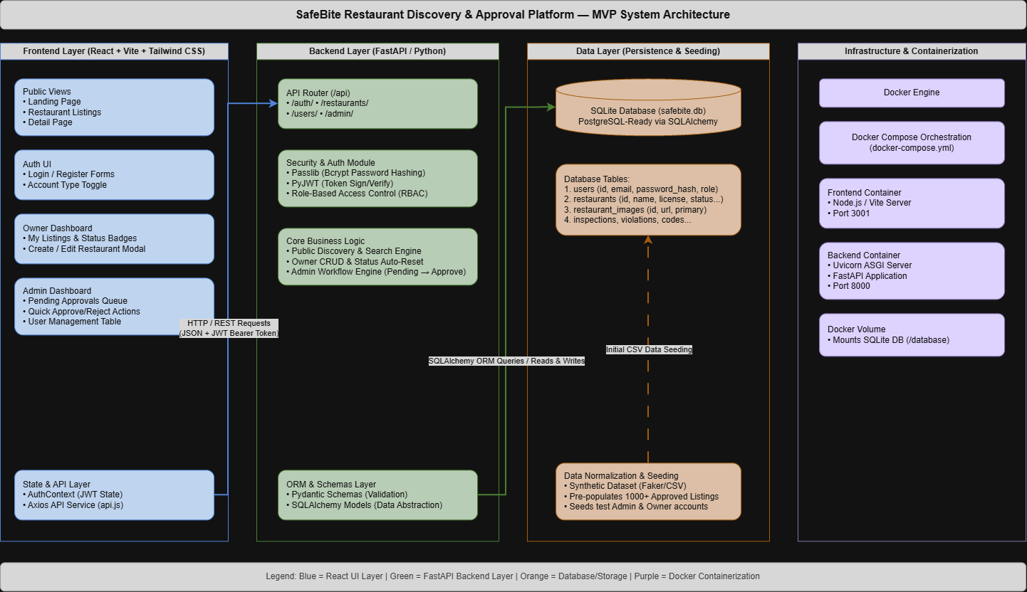
Figure: SafeBite End-to-End System Architecture Diagram.
5.2 Component Diagram
The component diagram details internal subsystems: Auth Module, Restaurant Service, Assessment Engine, Inspection Service, Ingestion Pipeline, and the Browser Extension Content Script bridge.
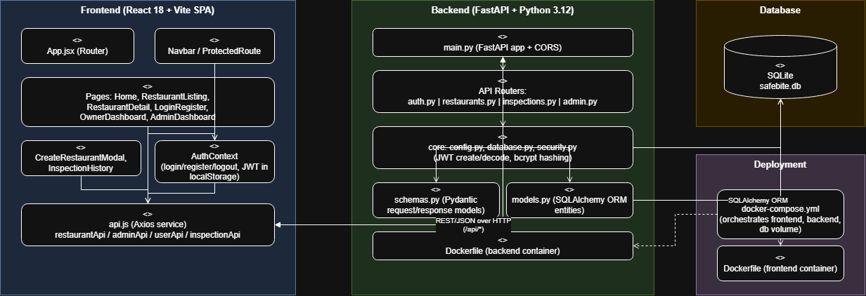
Figure: SafeBite Component Architecture Diagram.
5.3 Entity-Relationship (ER) Diagram
The relational data model comprises Users (with roles), Restaurants (with provenance attributes), Inspections, Violations, Inspectors, Complaints, and Correction Requests (for owner disputes).
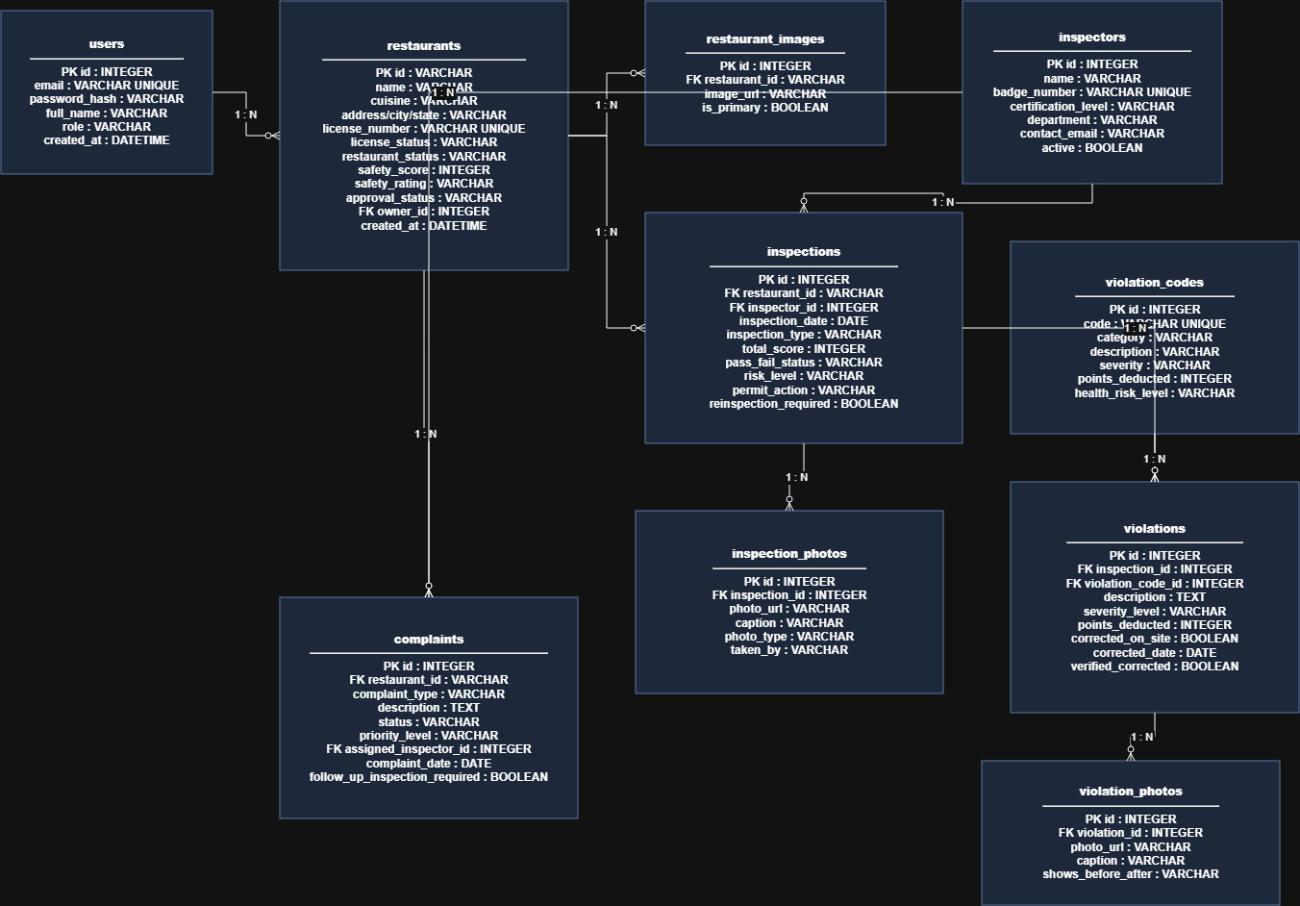
Figure: SafeBite Relational Entity-Relationship (ER) Diagram.
5.4 Class Diagram
The structural class diagram defines the object-oriented abstractions, schemas, Pydantic data models, and ORM entity relationships.
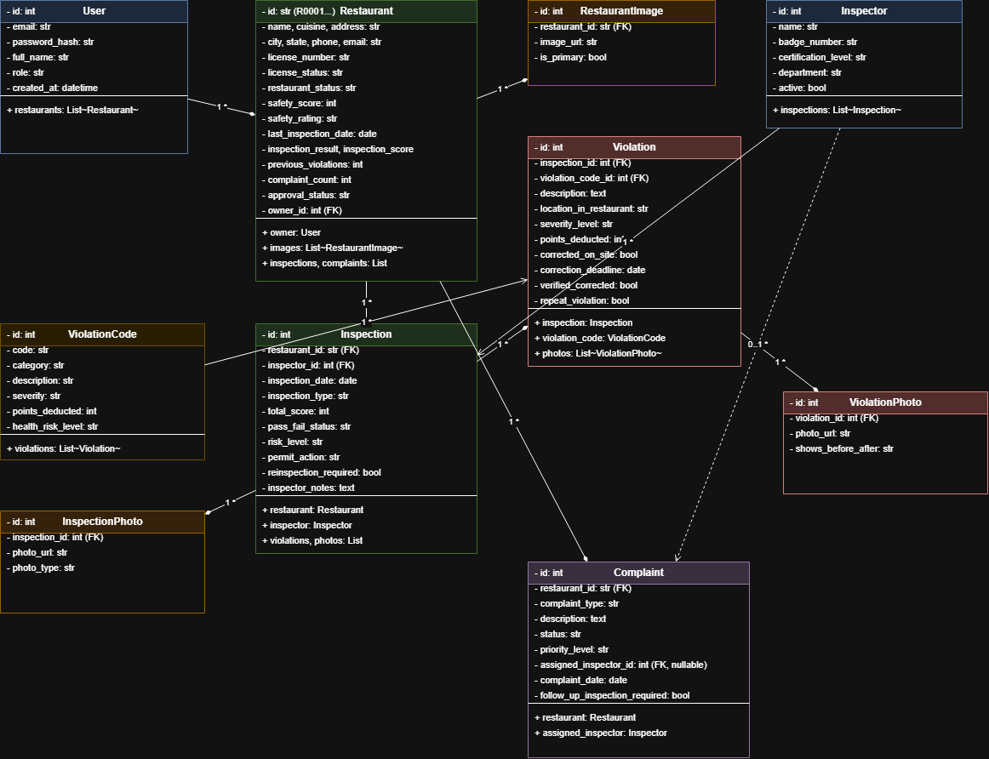
Figure: SafeBite Structural Class Diagram.
5.5 Use Case Diagram
Depicts system actors (Customer, Restaurant Owner, Health Inspector, Administrator) and their interactions with core platform features.
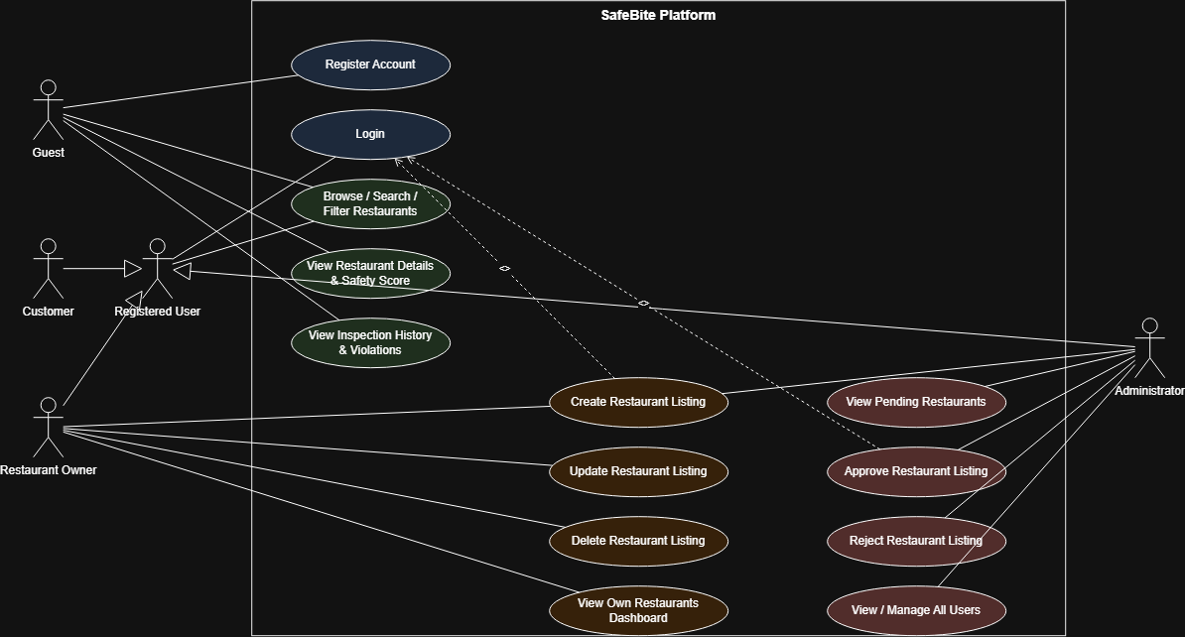
Figure: SafeBite System Use Case Diagram.
5.6 Sequence Diagram
Traces the chronological message sequence during restaurant matching, assessment evaluation, and safety modal rendering.
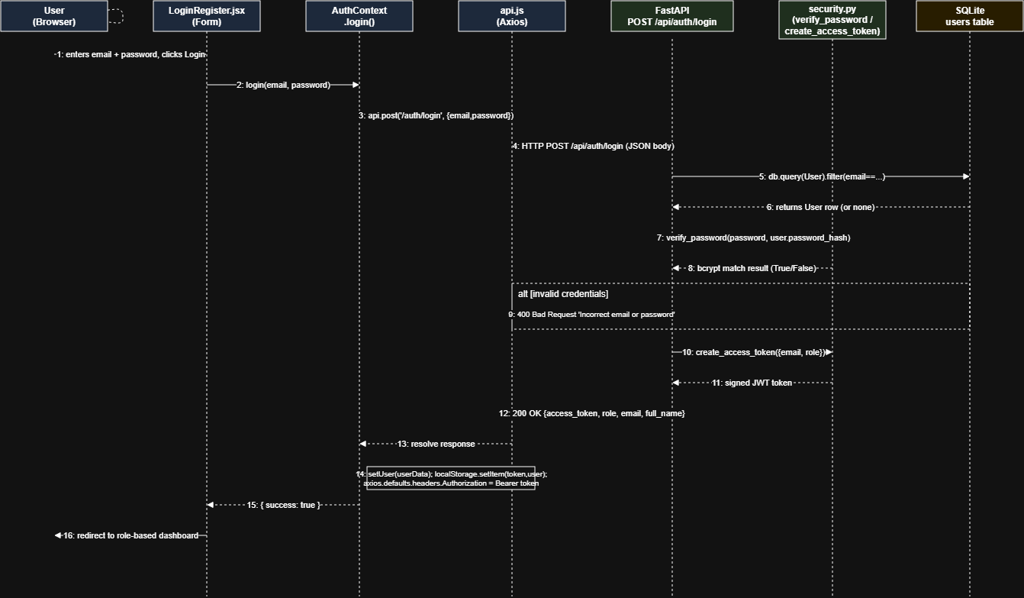
Figure: SafeBite Restaurant Assessment Sequence Diagram.

Section 6: Instructions for Reproducing the Project Demo
Step-by-Step Evaluator Reproduction Walkthrough
Follow these exact steps to reproduce and verify the SafeBite platform from source code:
Step 1: Install Dependencies
cd backend && pip install -r requirements.txt reportlab selenium
cd ../frontend && npm install
Step 2: Database Migration & Data Ingestion
cd backend
python migrate_db.py
python ingest_inspection_data.py
Step 3: Run Automated Test Suites
cd backend
pytest -v # 23 Automated tests pass (100% Green)
python tests/run_mutation_testing.py # 7/7 Mutants killed (100% Score)
Step 4: Start Backend & Frontend
Terminal 1 (Backend): python -m uvicorn app.main:app --host 127.0.0.1 --port 8000
Terminal 2 (Frontend): cd frontend && npm run dev (or npx vite preview)
Step 5: Open Application & Demo
1. Open Browser: http://localhost:5173/
2. Filter by Provenance: http://localhost:5173/restaurants (Select 'Verified Official')
3. Restaurant Detail: http://localhost:5173/restaurants/R0001 (Explainable score breakdown)
4. Submit Owner Dispute: Click 'Submit Data Correction / Dispute'
5. Companion Ordering Demo: http://localhost:5173/demo/order (Add items, click 'View Safety Audit Breakdown')
6. Admin Moderation: http://localhost:5173/admin/dashboard (admin@safebite.demo / adminpassword)

